**Introduction to Networks**

**CO1507**

**Tutorial**

**TCP/IP ARP Error Control**

***Instructions:***

Answer the following questions on a separate paper and keep both the tutorial sheet and the answers.

1. Compare OSI and TCP/IP models.

* The OSI model has 7 sections but the TCP/IP model has 4.
* Network changes to Interwork in TCP/IP model.
* Data Link and Physical are one layer in TCP/IP.

|  |  |  |
| --- | --- | --- |
| Application |  | Application |
| Presentation |
| Session |
| Transport |  | Transport |
| Network |  | Internetwork |
| Data Link |  | Link and  Physical |
| Physical |

2. Compare TCP and UDP transport protocols.

TCP 🡪 Transmission Control Protocol

UDP 🡪 User Datagram Protocol

TCP is reliable, it has flow control, built in error correction and all packets sent will arrive with acknowledgement.

It is usually used in critical scenarios where it is needed to confirm the delivery of the packets such as important emails (marked with the high importance icon (!)).

UDP on the other hand is unreliable, has no flow control, no error correction or synchronisation.

Packets sent are cannot be confirmed if they have arrived or not however it is used in applications that require priority over reliability such as video chat or Voice over IP.

3. Explain why UDP is used for video conferencing over TCP.

As mentioned in previous answer those kind of services require priority rather than reliability.

4. Draw a block diagram showing the various TCP/IP layers.

|  |
| --- |
| Application |
|
|
| Transport |
| Internetwork |
| Link and  Physical |
|

5. What are some of the causes of errors on a communication line?

Corrupted data (data that have been changed) and lost data. Networks should be designed to prevent, detect and correct both corrupted data and lost data. We begin by examining the sources of errors and how to prevent them and then turn to error detection and correction.

6. Explain how parity check is able to detect errors?

A parity bit is an extra 0 or 1 bit attached to a code group at transmission. In the even parity method the value of the bit is chosen so that the total number of 1s in the code group, including the parity bit, is an even number. For example, in transmitting 1001 the parity bit used would be 0 to give 01001, and thus an even number of 1s. In transmitting 1101 the parity bit used would be 1 to give 11101, and thus an even number of 1s. With odd parity the parity bit is chosen so that the total number of 1s, including the parity bit, is odd. Thus if at the receiver the number of 1s in a code group does not give the required parity, the receiver will know that there is an error and can request that the code group be retransmitted.

7. What is the limitation of parity check?

* Parity Bit Corruption - Corruption of the parity bit itself during transmission can cause the receiving station to discard valid data.
* Data Bit Corruption - Corruption of more than one bit in the byte/word will leave the number of binary 1's in the byte the same, but change the data's actual value. This corrupts the data but prevents the receiving device from detecting the error because parity still matches
* Combination - Both the parity bit and a bit in the data is corrupted such that the data and parity bit match, but the data is corrupted.

8. Assuming using odd parity what is the parity bit of 11101010 and 10101011

11101010 🡪 11101010 **|** 0

10101011 🡪 10101011 **|** 0

9. Assuming using even parity what is the parity bit of 10101010 and 11101011

10101010 🡪 10101010 **|** 0

11101011 🡪 11101011 **|** 0

10. Explain how CRC is used to check errors.

* The binary file will be divided by another standard polynomial (binary number).
* At the end of the division we get a remainder, this remainder is the CRC.
* The CRC is attached to the end of the information frame and sent on the line.
* The receiver re computes the frame, compare with the received frame
* If there is an error, it send a message to sender to ask it to resend the frame.

11. With the aid of frame diagrams, explain fully how Address Resolution Protocol (ARP) is used to locate the destination physical address of a computer on the segment. You need to draw ARP request, ARP reply showing the broadcast destination MAC address.

**192.168.20.3**

**IP: 192.168.20.2**

**A**

**B**

**MAC: 6a-21-23-3d-27-11**

**Source MAC address**

**6a-21-23-3d-27-11**

**Destination MAC address [broadcast]**

**FF-FF-FF-FF-FF-FF**

**Source IP address**

**192.168.20.2**

**Destination IP address**

**192.168.20.3**

**ARP Request**

12. What is meant by the term ‘broadcast is a necessary evil’?

13. What is the function of ARP table?

14. What is ICMP protocol?

15. In which situation do you get the response?

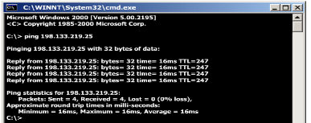

16. In which situation do you get the response?

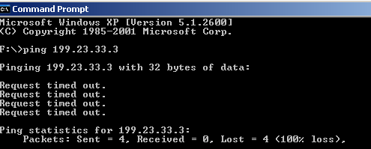

17. In which situation do you get the response?

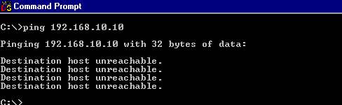

18. What is the effect of broadcast traffic on the network?

19. At which layer of the TCP/IP model does ARP operate? And why?

20. Go to YouTube and watch a tutorial about Wireshark.